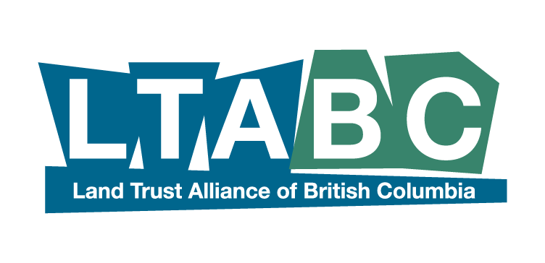
Media Advisory For Immediate release
February 28 2018

Future generations will thank us for protecting more of Canada.
BC Land Trusts protect some of Canada’s most important natural places

“Land trusts across BC and indeed across the country loudly applaud the Government of Canada’s commitment to nature and biodiversity conservation in Budget 2018. Canada is one of few remaining places on our planet with significant, intact natural areas, many of which are on private land in close proximity to urban centres” says Paul McNair, Executive Director of the Land Trust Alliance of BC.
McNair says that through community-based private land conservation, land trusts are uniquely positioned to leverage the government’s investment to help slow or reverse species declines, protect watersheds, and mitigate the effects of climate change.
Today’s budget announcement that the Government of Canada is contributing $1.3 billion in funding for environmental projects is a significant commitment on their part to ensure our country is a leader in conservation,” adds McNair, noting that the new Nature Fund of $500 million will likely allow non-profits and community groups to continue their remarkable efforts in places like the Okanagan Valley, Salt Spring Island, Nanaimo and more than 30 other communities across BC.
Throughout Canada, critical conservation work is being done on local and regional scales by the country’s land trusts. As community-driven, non-profit conservation organizations, land trusts work to protect important natural areas for the benefit of all by holding land in trust for future generations. Support by the federal government through the Natural Areas Conservation Program is an essential factor in land trusts’ ability to conduct their work and create protected natural areas in communities across the country.
Working with private landowners, land trusts protect critical ecosystem services in heavily populated regions of the country where traditional public land conservation approaches are either prohibitively expensive or impractical. By harnessing innovative partnerships with landowners and working with dedicated community volunteers, land trusts are able to establish conservation areas that protect critical habitat and create corridors between parks and other blocks of public and private land. This extension of connectivity and expansion of functional habitats is also critical to supporting Canada’s climate change resiliency.
A federal commitment to support private land conservation will accelerate the protection of biodiversity and vibrant natural areas from coast to coast. Canada’s community land trusts have already protected over 250,000 acres (101,000 hectares) of some of Canada's most ecologically significant land, including habitat for over 90 federally-listed species at risk. With sufficient government support, land trusts are poised to nearly double this amount within the next five years, protecting a potential 200,000 additional acres (81,000 hectares) of critical habitat.
The Land Trust Alliance of BC LTABC represents 35 land trusts across the province who have conserved more than 1500 pieces of private land and protected numerous species at risk. LTABC is also a member of Land Trusts Canada and a member of the Conservation Working Group designed to address federal funding including today’s budget announcements.
- 30 -
Further information:
Paul McNair, Executive Director
Land Trust Alliance of BC
paul@ltabc.ca 250-590-1921

