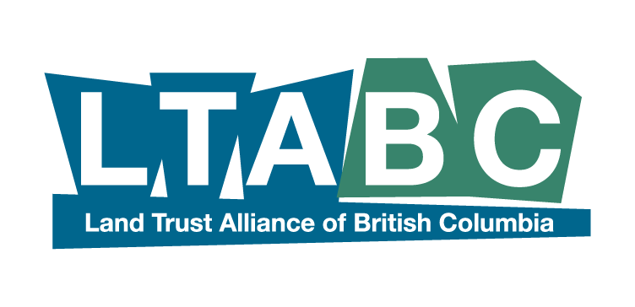

Canadian Land Trust - Standards and Practices

Resolution for Board Adoption

The Land Trust Alliance of British Columbia (LTABC) requires that all members of LTABC accept the Canadian Land Trust Standards and Practices as their guiding principles for governance and operations of the organization. Some public or private funders also ask for this confirmation by formal resolution or statement. Members also agree to engage in learning and assessment programs as part of their ongoing commitment to growth in competence and excellence with the Standards and Practices (S&Ps).

WHEREAS, the ___________________________________________ [land trust] has reviewed the Canadian Land Trust Standards and Practices as currently published by the Centre for Land Conservation in 2019, and WHEREAS,

the ___________________________________________ [land trust] agrees the Canadian Land Trust Standards and Practices are the ethical and technical guidelines for the responsible operation of a land trust;

BE IT RESOLVED THAT the Board of Directors of the __________________________________________ [land trust], hereby accepts the Canadian Land Trust Standards and Practices as:
guidelines for operations of the organization,
commits to making continual progress toward implementation of the Standards and Practices,
agrees to participate in learning and assessment programs in co-operation with LTABC,
support as part of this ongoing commitment to the LTABC membership,
and to growing its professional competence and excellence in the Standards and Practices.

____________________________________Date Adopted

____________________________________Board Member ____________________________________Position

____________________________________ Signature

____________________________________Board Member _____________________________________Position

___________________________________ Signature

Please return original copy to : LTABC 201-569 Johnson St, VICTORIA, BC V8W 1M2

